Test part III

**Brokenout**: very drole

**Eoubreakout**: I played this game 12 times and never got to find out what it said. OK I did find out it was something about a new nation and possibly going forth… go on…you know you want to tell me…

**Ekeout**: That’s very, very funny, but no thanks

**Fakeout:** is diabolical. One of the best ones.

(in passing) I’m a nervous wreck

**Freakout:** the first time and one other I didn’t get a paddle but guess that’s all part of the freak out experience.

**Ghostbreakout:** was it something helping me that was the ghost? Creepy.

**Koutbrea**: Jees, as if it isn’t hard enough already

**Makeout**: beautiful. Liked this one a lot

**Outbreak:** Another very nice one. In one game I was nearly finished and my paddle and the ball didn’t have anywhere to move and it just flashed on and off. Scored 79

**Pongout:** funny but hard to play…. But you know that already

Recursive breakout: Once I figured I could just leave things alone and it would play itself things calmed down. What an amazing effect. The screen grab just can’t do it justice…must be art..

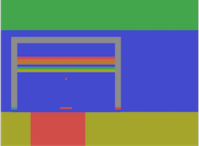

**Screenshakeout:** thought the paddle exploding was sensational, and surprising.

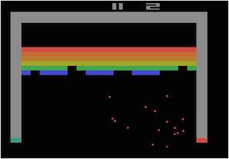

**Seriousbreakout:** I was this serious 380. Nice one.

**Shitbreakout:** can I take it that my ball got bogged down?

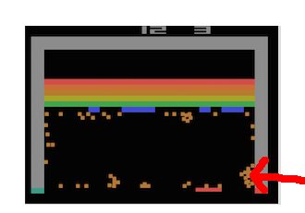

**Snakeout** is impossible for someone with my skills. I was pleased the few times I actually managed to hit the ball at all. Could it be played?

**Socialbreakout:** I played this 10 times but couldn’t finish at all. Does something happen in the end?

**Spaceout:** Wow that is a tough game. So many of these could be great games all on their own and that is one of them. Brilliant.

**Traceout:** One of my favourites. Love it. Looks fantastic and a great thing as the screen fills up trying to locate the ball.

**Tragicbreakout:** Awww I watched my little brick’s soul go on its way up to heaven. Cute…very cute. Love it.

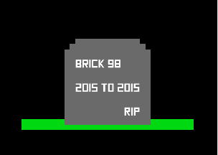

**Travelbreakout:** think there is a problem. Thought the request for location was great…

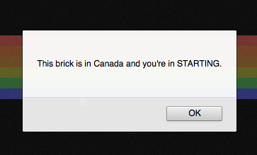



and on the second go got the NZ location in.

Then it kept requesting location until a sign came up asking to stop.



When I ticked the box and said ok the game froze after hitting the ball.

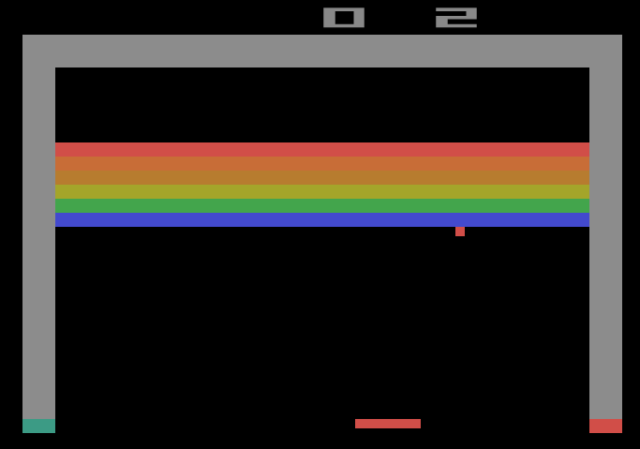

Actually it froze the whole browser screen.

**Treeoflifebreakout:** I was so busy playing I never got to read what the nuns taught us. Having said that I was pleased to find out that…



**Unfairbreakout**: well, you see for me that is totally fair and, I might say, the only way I get to finish a game.

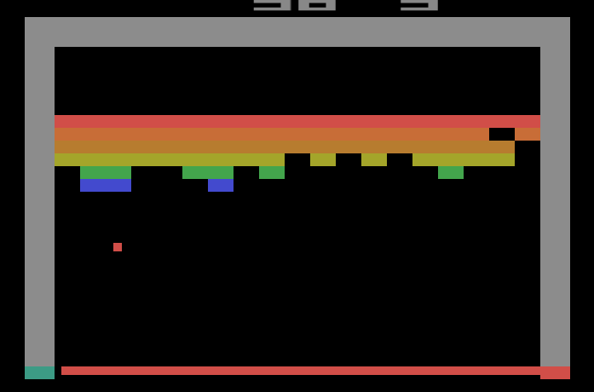

How about that it got a brick out in the middle of a row!

And a nice Michelangelo moment

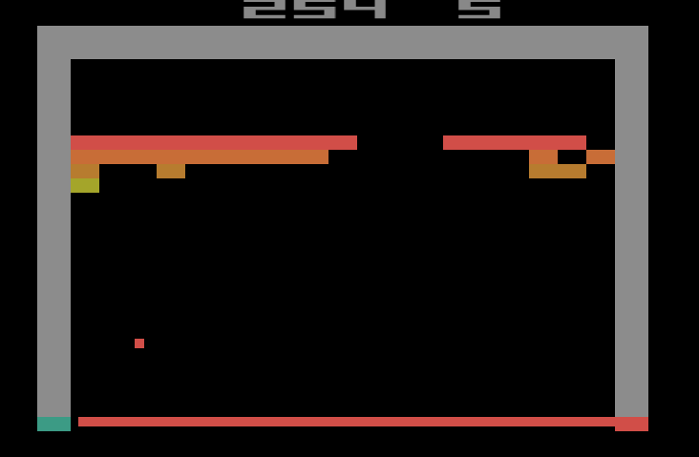

and after waiting for it to get every brick, which it did eventually, it started another game! And how did the other side get 5 points may I ask?

And now, the last one…

Zenosbreakout: oh for God’s sake!

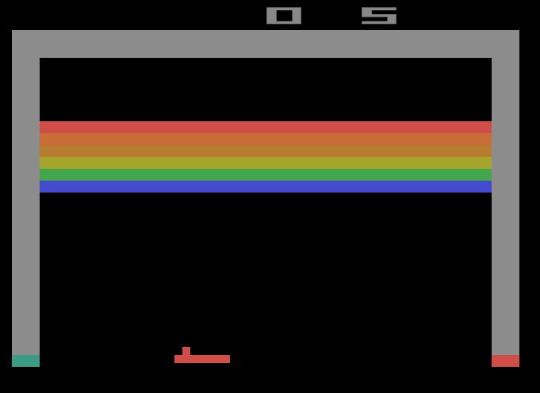

OK, are we talking Mormon Zenos? I guess not…the Zenos paradox huh! So very, very Pippin Barr. Congratulations.

Wonderful, the whole thing.

J